**WELCOME TO AJUWAYA CONNECT**

**This is an illustration to Ajuwaya Connect Application Structure**

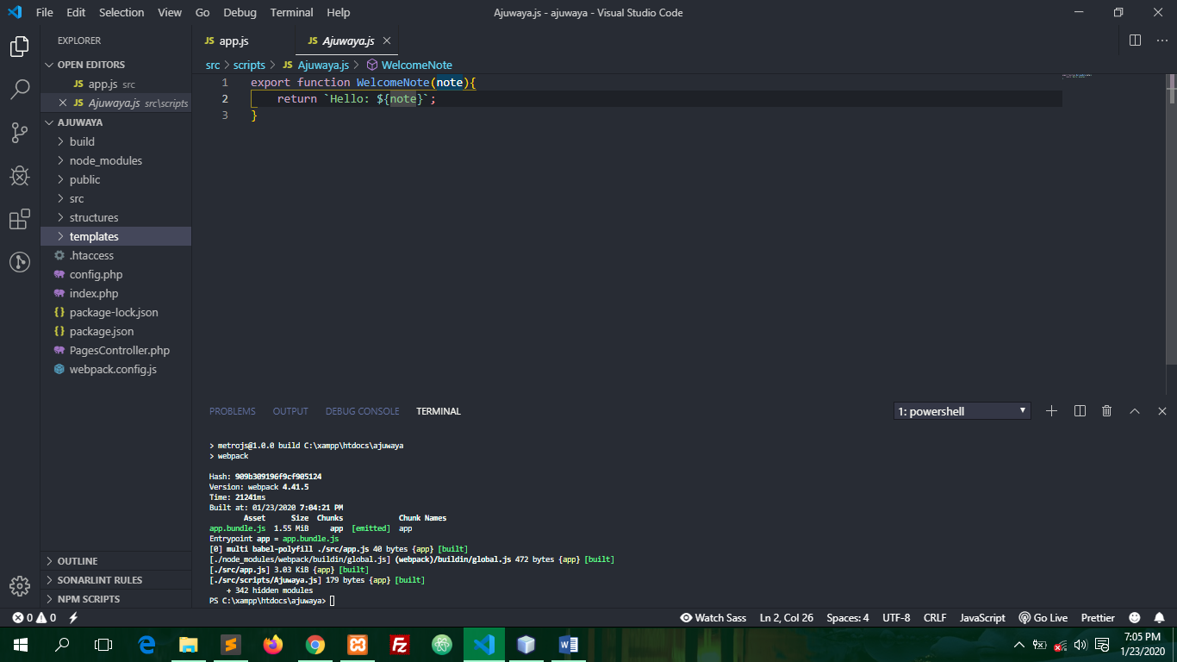

* **Build**
* **Public**
* **Src**
* **Structure**
* **Templates**
* **.htaccess**
* **Config.php**
* **Package.json**
* **PageController.php**
* **Webpack.config.js**

**Build**

Build consist of bundle.js files and external plugins. Filename.bundle.js are compiled files from the JavaScript Compiler (Such as Babel.Js).

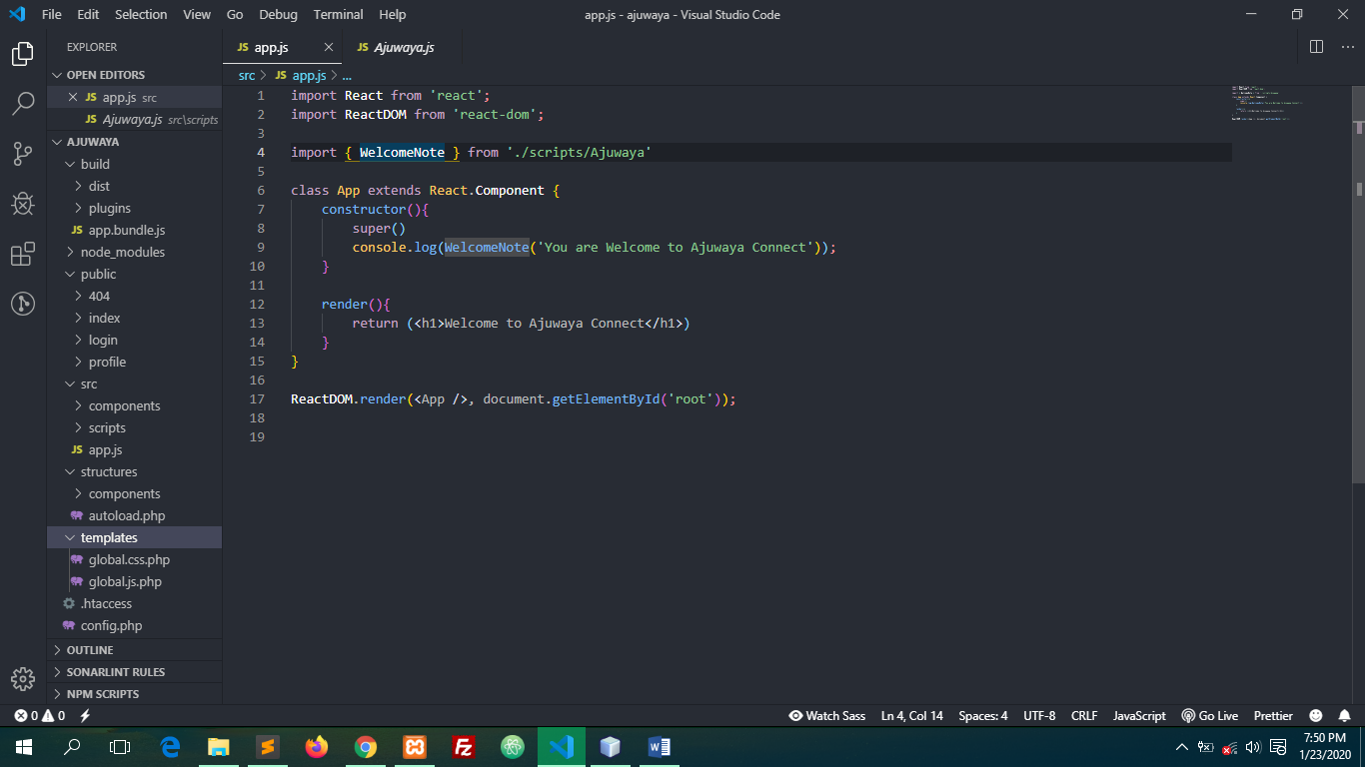**Public**

Public directory consists of public view (html structures). The directory is structure with backend routing and to create a new url. A folder has to be created in name of the url and add **index.php** to the folder

**Src**

This is the directory webpack.config.js file target for compilation and it’s the directory that consists of JavaScript Code that needs to be compiled.

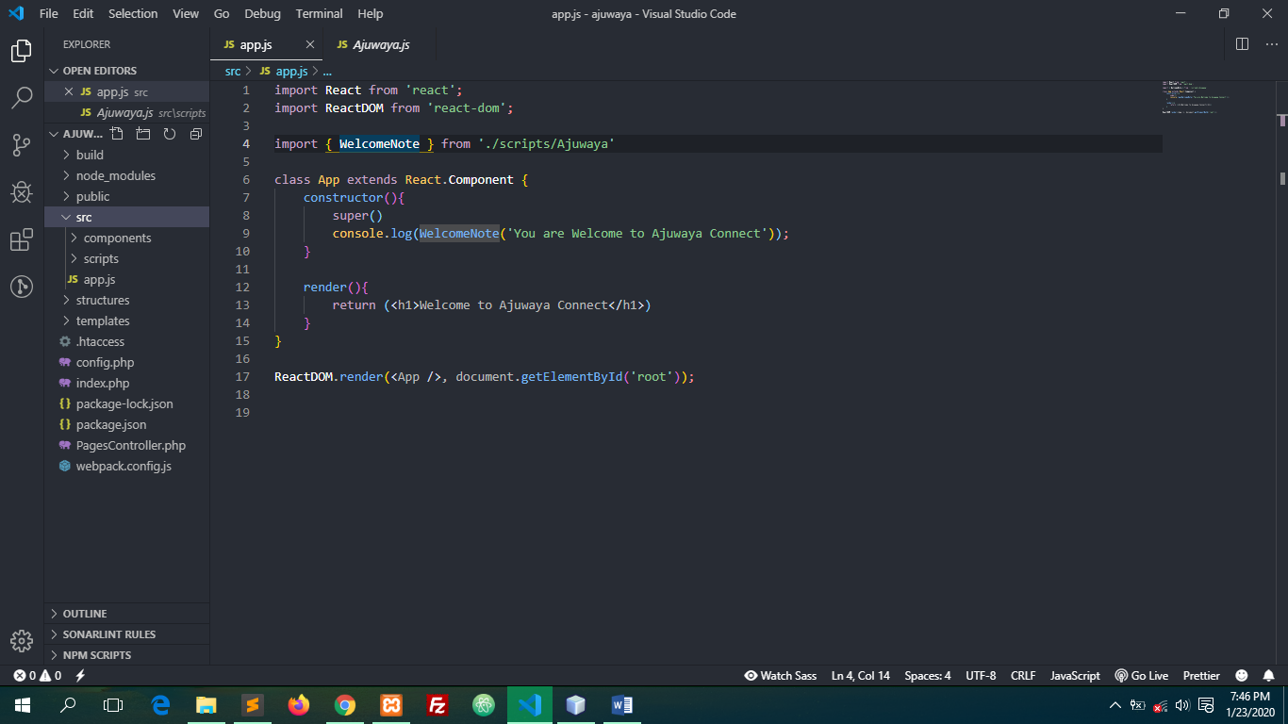

App.js is the target file for babel.js so as to compile all es6+ syntax to es5. Note that, you can add as much as files like app.js in as much you change the target file in webpack.config.js

**Structures**



This Directory is used by backend to structure MVC alike modules

**Templates**



This Directory is Optional and it’s a directory that consists of template for work-flow

**Webpack.config.js**

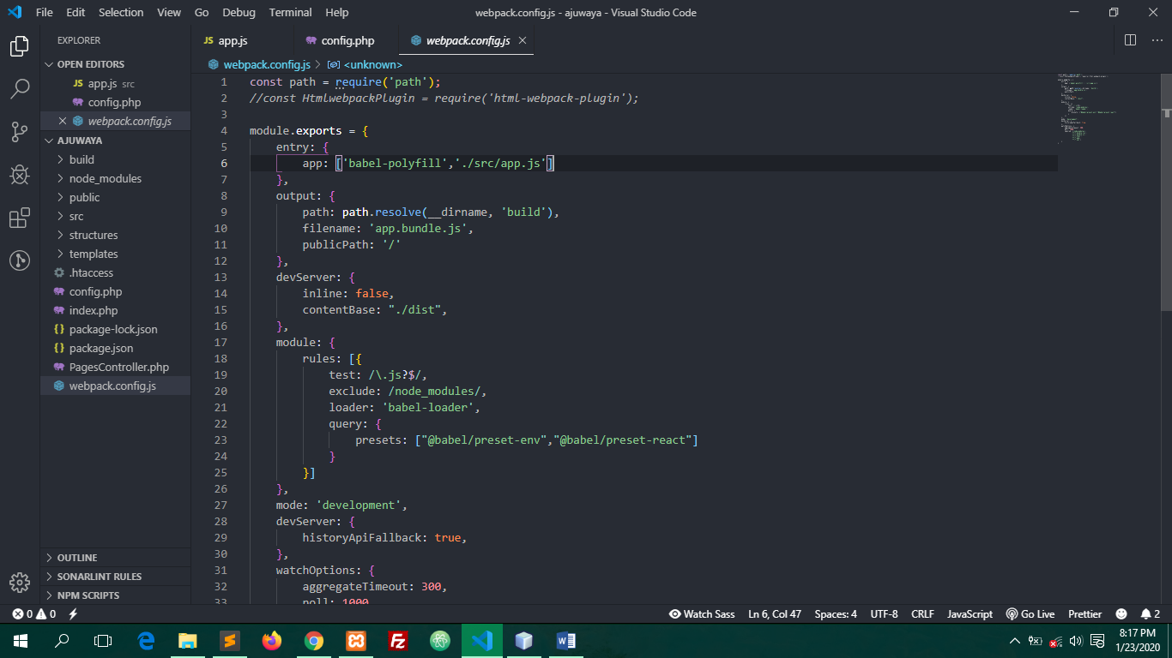

To add new entry file:

Change

entry: {

        app: ['babel-polyfill','./src/app.js']

    }

To

entry: {

        app: ['babel-polyfill','./src/new-filename.js']

    }

And Change

 output: {

        path: path.resolve(__dirname, 'build'),

        filename: 'app.bundle.js',

        publicPath: '/'

    }

To

 output: {

        path: path.resolve(__dirname, 'build'),

        filename: new-filename.bundle.js',

        publicPath: '/'

    }

Then Compile by using **npm run build**